**POWER SYSTEMS-II**

**UNIT-VI**

**MECHANICAL DESIGN OF OVERHEAD TRANSMISSION LINE**

**1. SAG IN OVERHEAD LINES**

  While erecting an overhead line, it is very important that conductors are under safe tension. If the conductors are too much stretched between supports in a bid to save conductor material, the stress in the conductor may reach unsafe value and in certain cases the conductor may break due to excessive tension. In order to permit safe tension in the conductors, they are not fully stretched but are allowed to have a dip or sag. The difference in level between points of supports and the lowest point on the conductor is called sag. Following Fig. shows a conductor suspended between two equal level supports A and B. The conductor is not fully stretched but is allowed to have a dip. The lowest point on the conductor is O and the sag is S. The following points may be noted

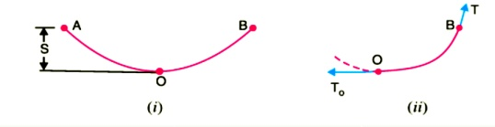

(i)  When the conductor is suspended between two supports at the same level, it takes the shap e of catenary. However, if the sag is very small compared with the span, then sag-span curve is like a parabola.

 (ii)The tension at any point on the conductor acts tangentially. Thus tension TO at the lowest Point O acts horizontally as shown in Fig. (ii).

(iii)The horizontal component of tension is constant throughout the length of the wire.

 (iv)The tension at supports is approximately equal to the horizontal tension acting at any point on the wire. Thus if T is the tension at the support B, then T = TO

**Conductor Sag And Tension**

This is an important consideration in the mechanical design of overhead lines. The conductor sag should be kept to a minimum in order to reduce the conductor material required and to avoid extra pole height for sufficient clearance above ground level. It is also desirable that tension in the conductor should be low to avoid the mechanical failure of conductor and to permit the use of less strong supports. However, low conductor tension and minimum sag are not possible. It is because low sag means a tight wire and high tension, whereas a low tension means a loose wire and increased sag. Therefore, in actual practice, a compromise in made between the two.

**2. CALCULATION OF SAG**

In an overhead line, the sag should be so adjusted that tension in the conductors is within safe limits. The tension is governed by conductor weight, effects of wind, ice loading and temperature variations. It is a standard practice to keep conductor tension less than 50% of its ultimate tensile strength i.e., minimum factor of safety in respect of conductor tension should be 2. We shall now calculate sag and tension of a conductor when ( i ) supports are at equal levels and ( ii ) supports are at unequal levels.

  When supports are at equal levels .Consider a conductor between two equilevel supports A and B with O as the lowest point as shown in Fig.8.2. It can be proved that lowest point will be at a conductor between two equilevel supports A and B with O as the lowest point as shown in Fig. It can be proved that lowest point will be at the mid-span.

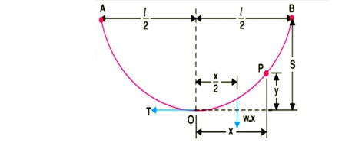

a conductor between two equilevel supports A and B with O as the lowest point as shown in Fig. It can be proved that lowest point will be at the mid-span.

Letl = Length of span

  w = Weight per unit length of conductor

 T = Tension in the conductor.

Consider a point P on the conductor. Taking the lowest point O as the origin, let the co-ordinates of point P be x and y. Assuming that the curvature is so small that curved length is equal to its horizontal projection ( i.e., OP = x ), the two forces acting on the portion OP of the conductor are :

(a)The weight wx  of conductor acting at a distance x/2 from O.

(b)   The tension T acting at O .

Equating the moments of above two forces about point O, we get,

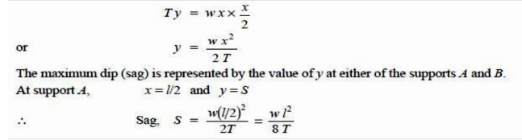

( ii ) When supports are at unequal levels. In hilly areas, we generally come across conductors suspended between supports at unequal levels. Fig.3 shows a conductor suspended between two supports A and B which are at different levels. The lowest point on the conductor is O .

Let

l         = Span length

h        = Difference in levels between two supports

x1 = Distance of support at lower level ( i.e., A ) from O

x2 = Distance of support at higher level ( i.e. B ) from O

T = Tension in the conductor

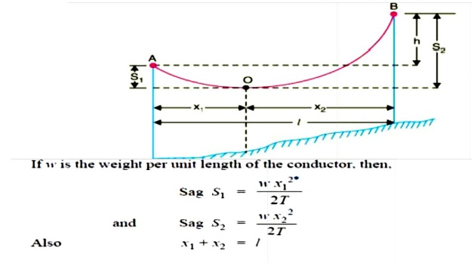

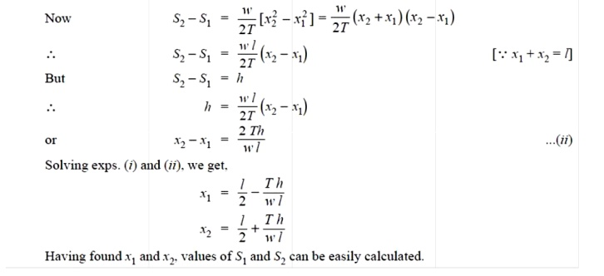

**3. EFFECT OF WIND AND ICE LOADING**

  The above formulae for sag are true only in still air and at normal temperature when the conductor is acted by its weight only. However, in actual practice, a conductor may have ice coating and simultaneously subjected to wind pressure. The weight of ice acts vertically downwards i.e. , in the same direction as the weight of conductor. The force due to the wind is assumed to act horizontally i.e ., at right angle to the projected surface of the conductor. Hence, the total force on the conductor is the vector sum of horizontal and vertical forces as shown in

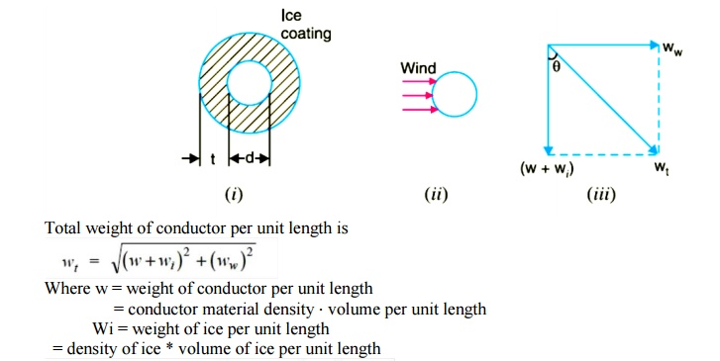

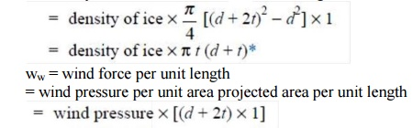

When the conductor has wind and ice loading also, the following points may be noted :

  i)The conductor sets itself in a plane at an angle to the vertical where

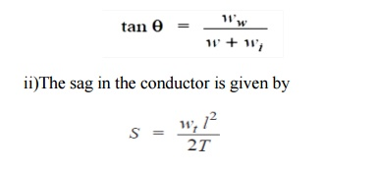

Hence S represents the slant sag in a direction making an angle to the vertical. If no specific mention is made in the problem, then slant slag is calculated by using the above formula.

tSF5amR

**4. STRINGING CHART**

 For use in the field work of stringing the conductors, temperature-sag and temperature tension charts are plotted for the given conductor and loading conditions. Such curves are called stringing charts (see Fig). These charts are very helpful while stringing overhead lines.

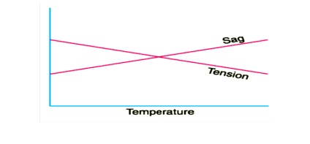

**OVERHEAD LINE INSULATOR**

**INTRODUCTION**

 Electrical Insulator must be used in electrical system to prevent unwanted flow of current to the earth from its supporting points. The insulator plays a vital role in electrical system. Electrical  Insulator is  a  very high  resistive  path       through  which  practically no current can  flow.  In  transmission  and       distribution  system,      the  overhead  conductors  are generally supported by supporting towers or poles. The towers and poles both are properly grounded. So there must be insulator between tower or pole body and current carrying conductors to prevent the flow of current from conductor to earth through the grounded supporting towers or poles.

**1. INSULATING MATERIAL**

The main cause of failure of overhead line insulator, is flash over, occurs in between line and earth during abnormal over voltage in the system. During this flash over, the huge heat produced by arcing, causes puncher in insulator body. Viewing this phenomenon the materials used for electrical insulator, has to posses some specific properties.

**Properties of insulating material**

  The materials generally used for insulating purpose is called **insulating material**. For successful utilization, this material should have some specific properties as listed below-

1.It must be mechanically strong enough to carry tension and weight of conductors.

 2.  It must have very high dielectric strength to withstand the voltage stresses in High Voltage system.

 3. It must possess high Insulation Resistance to prevent leakage current to the earth.

 4. There physical as well as electrical properties must be less affected by changing temperature

**Porcelain**

  Porcelain in most commonly used material for over head insulator in present days. The porcelain is aluminium silicate. The aluminium silicate is mixed with plastic kaolin, feldspar and quartz to obtain final hard and glazed **porcelain insulator** material. The surface of the insulator should be glazed enough so that water should not be traced on it. Porcelain also should be free from porosity since porosity is the main cause of deterioration of its dielectric property. It must also be free from any impurity and air bubble inside the material which may affect the insulator properties.

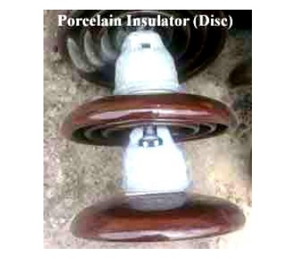

**Glass Insulator**

  Now days **glass insulator** has become popular in transmission and distribution system. Annealed tough glass is used for insulating purpose. Glass insulator has numbers of advantages over conventional porcelain insulator

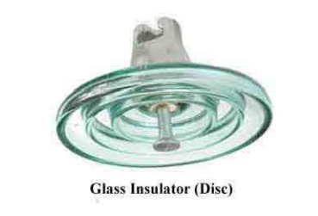

**Advantage**

1.It has very high dielectric strength compared to porcelain.

2. Its resistivity is also very high.

3. It has low coefficient of thermal expansion.

4. It has higher tensile strength compared to porcelain insulator.

5. As it is transparent in nature is not heated up in sunlight as porcelain.

6. The impurities and air bubble can be easily detected inside the glass insulator body because of its transparency.

7. Glass has very long service life as because mechanical and electrical properties of glass do not be affected by ageing.

8. After all, glass is cheaper than porcelain.

**Disadvantage**

 1.       Moisture can easily condensed on glass surface and hence air dust will be deposited on the wed glass surface which will provide path to the leakage current of the system.

 2.       For higher voltage glass cannot be cast in irregular shapes since due to irregular cooling internal cooling internal strains are caused.

**Polymer Insulator**

  In a **polymer insulator** has two parts, one is glass fiber reinforced epoxy resin rod shaped core and other is silicone rubber or EPDM (Ethylene Propylene Diene Monomer) made weather sheds. Rod shaped core is covered by weather sheds. Weather sheds protect the insulator core from outside environment. As it is made of two parts, core and weather sheds,**polymer** **insulator** is also called **composite insulator**. The rod shaped core is fixed with Hop dipgalvanized cast steel made end fittings in both sides.

**Advantage**

1.It is very light weight compared to porcelain and glass insulator.

2. As the **composite insulator** is flexible the chance of breakage becomes minimum.

3. Because of lighter in weight and smaller in size, this insulator has lower installation cost.

  4. It has higher tensile strength compared to porcelain insulator.

  5. Its performance is better particularly in polluted areas.

6. Due to lighter weight polymer insulator imposes less load to the supporting structure.

  7. Less cleaning is required du e to hydrophobic nature of the insulator.

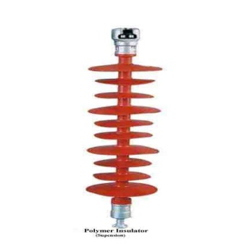

**Disadvantage**

 1. Moisture may enter in the core if there is any unwanted gap between core and weather sheds. This may cause electrical failure of the insulator.

 2. Over crimping in end fittings may result to cracks in the core which leads to mechanical failure of polymer insulator.

  In addition to these, some other disadvantages might be experienced. Let us give a practical example where many difficulties are faced in maintaining a distribution network in Victoria Australia due to polymeric insulator.

  There are many Cockatoos, Galahs & Parrots in that area of Australia, which love to chew on polymeric strain insulators. Here, the 22KV network has many of polymeric strain insulators installed and now after a few years of installing polymeric strain insulators, the authority is now replacing many of them back with Glass disc insulators.

  Another disadvantage is that they have had post type polymeric insulators melt and bend in bushfire areas. They have a concrete pole and a steel cross arm that survives a bushfire, however the polymers in some cases fail. This would not be the case with glass or porcelain insulators.

  They have also had polymeric insulators fail in areas close to the ocean coastline where there are high salt levels in the air.

  1.     Subject to bird attack by Parrots, Cockatoos & Galahs.

2.     Not resilient to bushfire temperatures.

3.     Not recommended for location near surf beaches due to salt spray.

**TYPES OF INSULATOR**

There are mainly three types of insulator likewise

1. Pin Insulator

2. Suspension Insulator

3. Stray Insulator

4. Shackle Insulators

5. Stay Insulator

  In addition to that there are other two types of electrical insulator available mainly for low voltage application i.e. stay insulator and shackle insulator.

**1. Pin Type Insulators**

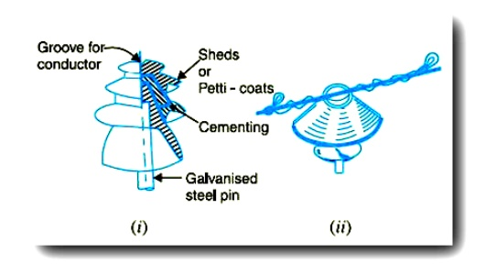

As the name suggests, the pin type insulator is secured to the cross-arm on the pole. There is a groove on the upper end of the insulator for housing the conductor. The conductor passes through this groove and is bound by the annealed wire of the same material as the conductor. Pin type insulators are used for transmission and distribution of electric power at voltages up to 33 kV. Beyond operating voltage of 33 kV, the pin type insulators become too bulky and hence uneconomical.

**Causes of Insulator Failures:**

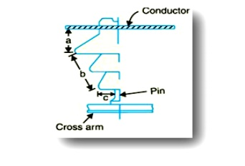

Insulators are required to withstand both mechanical and electrical stresses. The latter type is primarily due to line voltage and may cause the breakdown of the insulator. The electrical breakdown of the insulator can occur either by flash-over or puncture. In flashover, an arc occurs between the line conductor and insulator pin (i.e., earth) and the discharge jumps across the air gaps, following shortest distance. Figure shows the arcing distance (i.e. a + b + c) for the insulator. In case of flash-over, the insulator will continue to act in its proper capacity unless extreme heat produced by the arc destroys the insulator. In case of puncture, the discharge occurs from conductor to pin through the body of the insulator. When such breakdown is involved, the insulator is permanently destroyed due to excessive heat. In practice, sufficient thickness of porcelain is provided in the insulator to avoid puncture by the line voltage. The ratio of puncture strength to flashover voltage is known as safety factor.

**2. Suspension Type**

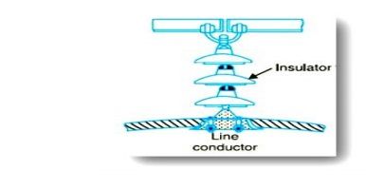

For high voltages (>33 kV), it is a usual practice to use suspension type insulators shown in Figure. Consist of a number of porcelain discs connected in series by metal links in the form of a string. The conductor is suspended at the bottom end of this string while the other end of the string is secured to the cross-arm of the tower. Each unit or disc is designed for low voltage, say 11 kV. The number of discs in series would obviously depend upon the working voltage. For instance, if the working voltage is 66 kV, then six discs in series will be provided on the string.

**Advantages of suspension type:**

Suspension type insulators are cheaper than pin type insulators for voltages beyond 33 kV.

Each unit or disc of suspension type insulator is designed for low voltage, usually 11 kV. Depending upon the working voltage, the desired number of discs can be connected in series.

  If anyone disc is damaged, the whole string does not become useless because the damaged disc can be replaced.

The suspension arrangement provides greater flexibility to the line. The connection at the cross arm is such that insulator string is free to swing in any direction and can take up the position where mechanical stresses are minimum.

In case of increased demand on the transmission line, it is found more satisfactory to supply the greater demand by raising the line voltage than to provide another set of conductors. The additional insulation required for the raised voltage can be easily obtained in the suspension arrangement by adding the desired number of discs.

The suspension type insulators are generally used with steel towers. As the conductors run below the earthed cross-arm of the tower, therefore, this arrangement provides partial protection from lightning.

**3. Strain Insulators**

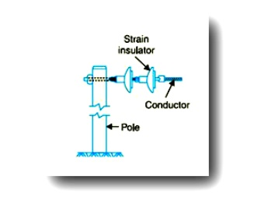

When there is a dead end of the line or there is corner or sharp curve, the line is subjected to greater tension. In order to relieve the line of excessive tension, strain insulators are used. For low voltage lines (< 11 kV), shackle insulators are used as strain insulators. However, for high voltage transmission lines, strain insulator consists of an assembly of suspension insulators as shown in Figure. The discs of strain insulators are used in the vertical plane. When the tension in lines is exceedingly high, at long river spans, two or more strings are used in parallel.

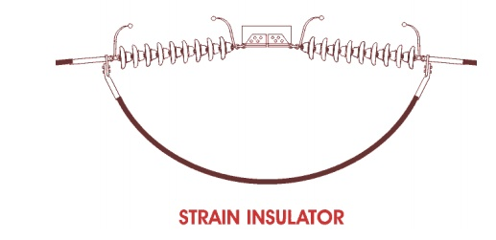

**4. Shackle Insulators**

  In early days, the shackle insulators were used as strain insulators. But now a day, they are frequently used for low voltage distribution lines. Such insulators can be used either in a horizontal position or in a vertical position. They can be directly fixed to the pole with a bolt or to the cross arm.

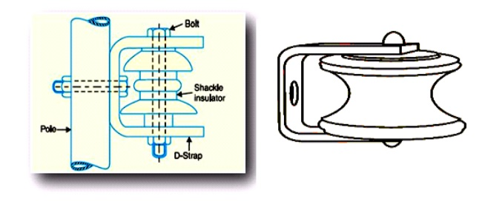

**5. Stay Insulator**

  For low voltage lines, the stays are to be insulated from ground at a height. The insulator used in the stay wire is called as the **stay insulator** and is usually of porcelain and is so designed that in case of breakage of the insulator the guy-wire will not fall to the ground. There are several methods of increasing the string efficiency or improving voltage distribution across different units of a string.

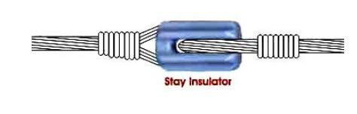

**POTENTIAL DISTRIBUTION OVER SUSPENSION INSULATOR STRING**

A string of suspension insulators consists of a number of porcelain discs connected in series through metallic links. Fig. shows 3-disc string of suspension insulators. The porcelain portion of each disc is in between two metal links. Therefore, each disc forms a capacitor C as shown in Fig. This is known as mutual capacitance or self-capacitance. If there were mutual capacitance alone, then charging current would have been the same through all the discs and consequently voltage across each unit would have been the same i.e., V/3 as shown However, in actual practice, capacitance also exists between metal fitting of each disc and tower or earth. This is known as shunt capacitance C1. Due to shunt capacitance, charging current is not the same through all the discs of the string Therefore, voltage across each disc will be different. Obviously, the disc nearest to the line conductor will have the maximum* voltage. Thus referring to Fig V3 will be much more than V2 or V1. The following points may be noted regarding the potential distribution over a string of suspension insulators:

 o   The voltage impressed on a string of suspension insulators does not distribute itself uniformly across the individual discs due to the presence of shunt capacitance.

 o   The disc nearest to the conductor has maximum voltage across it. As we move towards the cross-arm, the voltage across each disc goes on decreasing.

 o   The unit nearest to the conductor is under maximum electrical stress and is likely to be punctured. Therefore, means must be provided to equalize the potential across each unit.

 o   If the voltage impressed across the string were d.c., then voltage across each unit would be the same. It is because insulator capacitances are ineffective for d.c.

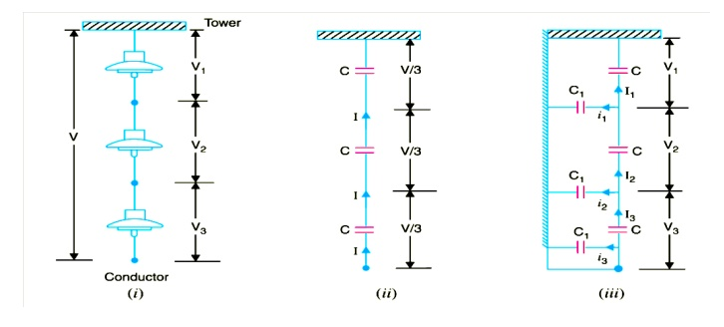

**STRING EFFICIENCY**

As  stated  above,  the  voltage  applied     across  the  string  of  suspension  insulators  is not uniformly distributed across various units or discs. The disc nearest to the conductor has much higher potential than the other discs. This unequal potential distribution is undesirable and is usually expressed in terms of string efficiency.

The ratio of voltage across the whole string to the product of number of discs and the voltage across the disc nearest to the conductor is known as string efficiency i.e.,

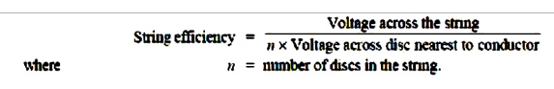

String efficiency is an important consideration since it decides the potential distribution along the string. The greater the string efficiency, the more uniform is the voltage distribution. Thus 100% string efficiency is an ideal case for which the voltage across each disc will be exactly the same. Although it is impossible to achieve 100% string efficiency, yet efforts should be made to improve it as close to this value as possible.

**Mathematical Expression.**Fig. Shows the equivalent circuit for a 3-disc string. Let us supposethat self capacitance of each disc is C. Let us further assume that shunt capacitance C1 is some fraction K of self capacitance i.e., C1 =KC. Starting from the cross-arm or tower, the voltage across each unit is V1,V2 and V3 respectively as shown.

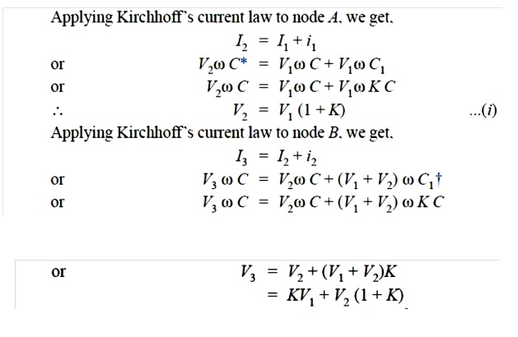

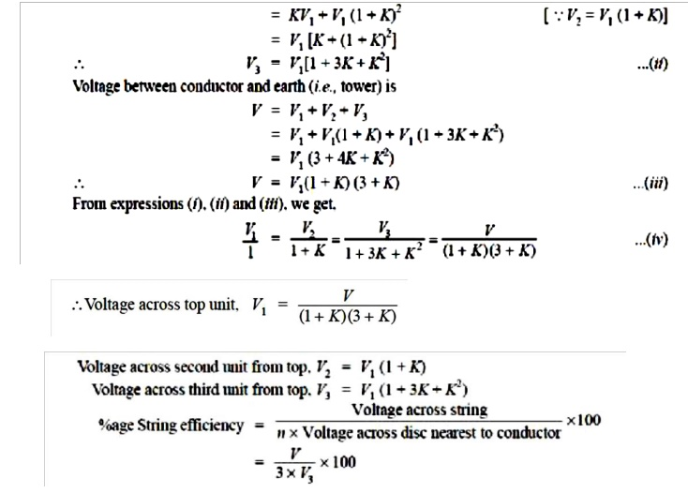

**The following Points may be noted from the above mathematical analysis**

(i)  If K = 0·2 (Say), then from exp. (iv), we get, V2 = 1·2 V1 and V3 = 1·64 V1. This clearly shows that disc nearest to the conductor has maximum voltage across it; the voltage across other discs decreasing progressively as the cross-arm in approached.

 (ii) The greater the value of K (= C1/C), the more non-uniform is the potential across the discs and lesser is the string efficiency.

 (iii) The inequality in voltage distribution increases with the increase of number of discs in the string. Therefore, shorter string has more efficiency than the larger one

**METHODS OF IMPROVING STRING EFFICIENCY**

It has been seen above that potential distribution in a string of suspension insulators is not uniform. The maximum voltage appears across the insulator nearest to the line conductor and decreases progressively as the cross arm is approached. If the insulation of the highest stressed insulator breaks down or flash over takes place, the breakdown of other units will take place in succession. This necessitates equalizing the potential across the various units of the string *i.e.* to improve the string efficiency. The various methods for this purpose are:

**(I)By Using Longer Cross-Arms**

 The value of string efficiency depends upon the value of K i.e., ratio of shunt capacitance to mutual capacitance. The lesser the value of K, the greater is the string efficiency and more uniform is the voltage distribution. The value of K can be decreased by reducing the shunt capacitance. In order to reduce shunt capacitance, the distance of conductor from tower must be increased i.e., longer cross-arms should be used. However, limitations of cost and strength of tower do not allow the use of very long cross-arms. In practice, K = 0·1 is the limit that can be achieved by this method.

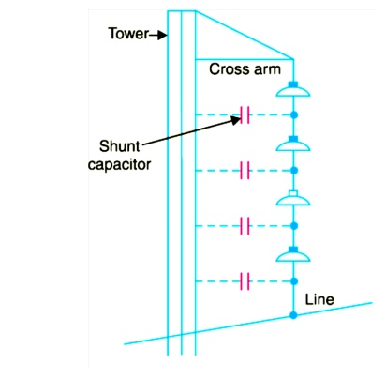

**(II) By Grading The Insulators**

  In this method, insulators of different dimensions are so chosen that each has a different capacitance. The insulators are capacitance graded i.e. they are assembled in the string in such a way that the top unit has the minimum capacitance, increasing progressively as the bottom unit (i.e., nearest to conductor) is reached. Since voltage is inversely proportional to capacitance, this method tends to equalize the potential distribution across the units in the string. This method has the disadvantage that a large number of different-sized insulators are required. However, good results can be obtained by using standard insulators for most of the string and larger units for that near to the line conductor.

**(III)By Using A Guard Ring**

  The potential across each unit in a string can be equalised by using a guard ring which is a metal ring electrically connected to the conductor and surrounding the bottom insulator as shown in the Fig The guard ring introduces capacitance between metal fittings and the line conductor. The guard ring is contoured in such a way that shunt capacitance currents i1, i2 etc. are equal to metal fitting line capacitance currents i′1, i′2 etc. The result is that same charging current I flows through each unit of string. Consequently, there will be uniform potential distribution across the units.

